Name: Manda Amose
1. Linux History:
- Linux was created in 1991 by Linus Torvalds as a Unix-like kernel.
- Initially, it was a hobby project to build a free OS for personal computers.
- Linux by itself is only the kernel, which:
- Manages hardware (CPU, memory, devices)
- Provides core system functions
- The GNU Project, started by Richard Stallman, contributed:
- Compilers (GCC)
- Shell (Bash)
- Utilities (core tools)
- Combining Linux kernel + GNU tools = GNU/Linux OS
2.Linux Philosophy:
- Linux follows strong design principles:
- Everything is a file
- Small programs that do one thing well
- Programs can be combined using pipes
- Emphasis on:
- Simplicity
- Modularity
- Flexibility
What is linux system?
1. The Bootloader:
This is the "starter motor" of your computer. When you turn on your machine, the bootloader is the first program that runs. Its only job is to manage the boot process and hand control over to the Kernel.
2. The Kernel:
The Kernel is the heart of the OS. It is the bridge between your hardware (CPU, RAM, Disk) and your software. It manages memory, schedules tasks, and handles peripheral devices.
3. Init System (Daemons):
Once the Kernel is loaded, it starts the Init System. This is the "parent" process that manages all other processes. It starts "daemons"—background services like printing, networking, and sound—that run silently to keep the system functional.
4. The Shell (Command Line):
The Shell is a text-based interface that allows you to talk to the Kernel. You type a command (like the cd command we discussed earlier), and the Shell interprets that command so the OS can execute it.

5. Graphical Server:
If you aren't using a purely text-based server, you need a Graphical Server. This is the sub-system that renders graphics on your screen. It handles how windows move and how pixels are displayed.
6. Desktop Environment:
This is what you actually see and interact with. It includes the windows, folders, toolbars, and wallpapers. It’s a bundle of applications (like file managers and settings) that provide a cohesive look and feel.
7. Applications:
These are the tools you use to get work done. Linux doesn't provide every app by default, but distributions come with "Package Managers" (like apt or dnf) that let you install thousands of programs easily.
3.Open Source Movement:
- Promotes free access to source code
- Users can:
- Study the code
- Modify it
- Redistribute it
- Governed by licenses like GPL (General Public License)
- Advantages:
- Transparency (no hidden code)
- Faster bug fixing (community support)
- Cost-effective (free software)
4. Popular Linux Distributions:
- A distribution (distro) is a complete OS built on Linux kernel.
- Includes:
- Kernel
- Package manager
- Desktop environment
- Pre-installed software
- Ubuntu:
- Based on Debian
- Beginner-friendly and widely used
- Strong community support
- Uses APT package manager

- Fedora:
- Developed by Red Hat community
- Uses latest technologies
- Stable but cutting-edge
- Uses DNF package manager
- CentOS:
- Enterprise-grade stability
- Used in servers
- Based on Red Hat Enterprise Linux
- Long-term support
5. Understanding Desktop Environments:
A desktop environment (DE) provides graphical user interface (GUI).
Components:
- Window manager
- File manager
- Panels and menus
- Settings tools
- GNOME:
- Clean and minimal interface
- Focus on productivity
- Default in Ubuntu

- KDE:
- Highly customizable
- Advanced features
- Uses Plasma desktop

- XFCE:
- Lightweight and fast
- Low resource usage
- Ideal for older systems

6.Command Line Basics:
- Terminal is a Command Line Interface (CLI).
- Users interact using commands instead of GUI.
- Common shell: Bash (Bourne Again Shell)
Advantages:
- Faster execution
- Automation through scripts
- Powerful control over system
Basic Navigation Commands:
- Pwd -> present working directory

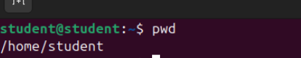
- ls -> lists directory contents

- cd -> change directory
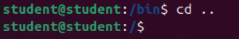

7. Directory Structures:
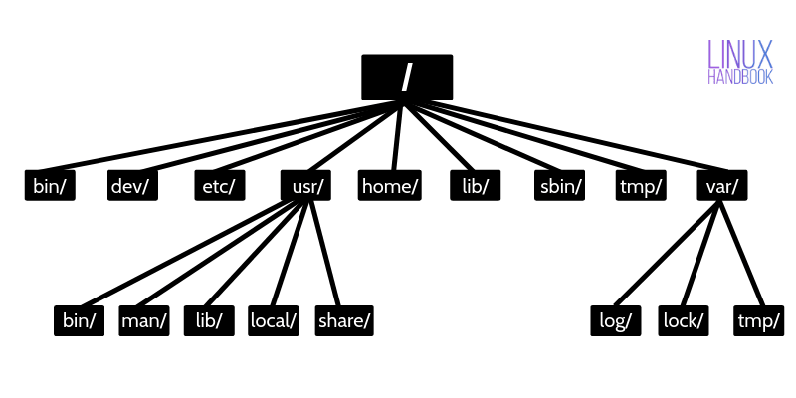
- Linux follows a hierarchical structure starting from root /.
- Important directories:
- / → root directory
- /home → user files
- /bin → essential commands
- /etc → system configurations
- /var → logs and variable data
- /usr → user programs
8.Absolute vs Relative Path:
- Absolute Path:
- Full path from root

- Relative Path:
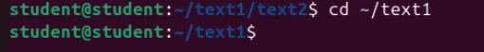
Path from current directory

9. File Management Commands:
- Creating Files and Directories:
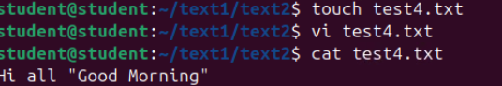
- touch file.txt → creates empty file

- mkdir folder → creates directory
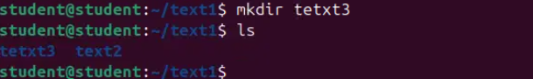

10.Listing Files:
- ls → basic listing
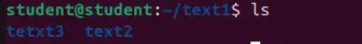

- ls -l → detailed info (permissions, size, owner)
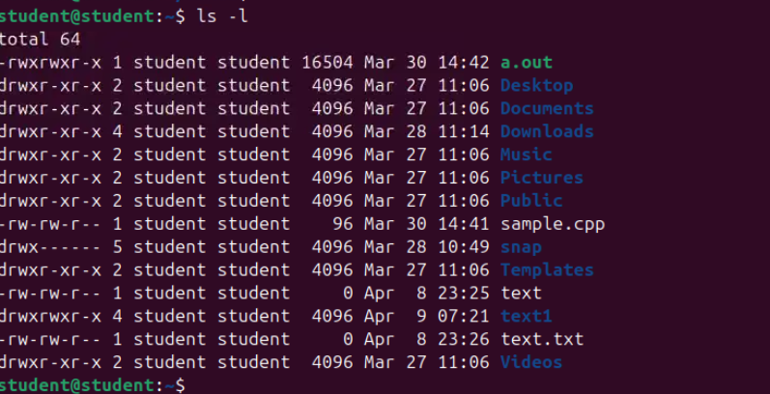

- ls -a → shows hidden files
